[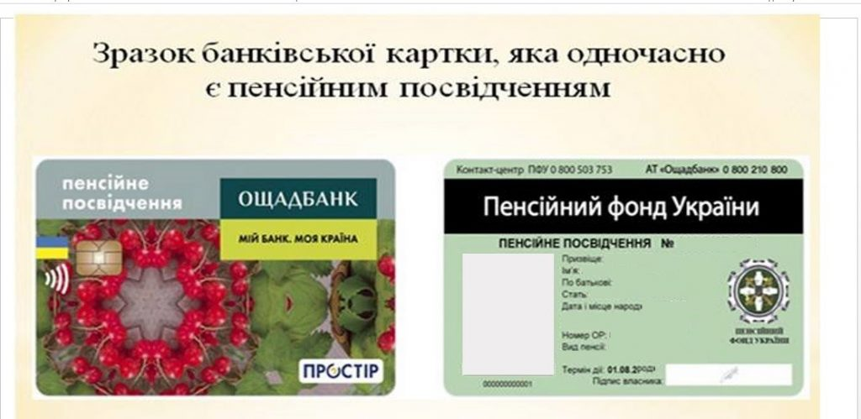](https://www.pfu.gov.ua/content/uploads/2018/09/1111A-1024x499.jpg)